Prop 2. | E. K Feusi

**Livestock as Ecosystem Engineers: Preventing Forest Encroachment in Nearctic Regions**

(Main stakeholders: farmers, researchers, env. Agencies)

Forest encroachment is a big issue in subarctic regions, as it causes permafrost to melt more rapidly. Ranchers typically employ clear-cutting/controlled burning to fix this issue, although this is not the most labor-efficient route: instead, an early-warning detection system can be used to find areas at the greatest risk of forest encroachment, which should be grazed heavily (as cattle can trample the shrubs before they should grow). This should be balanced, however, with the farmers pre-existing seasonal cattle rotation schedule, cattle preferences (for sufficient, tasty shrubs), and convenience.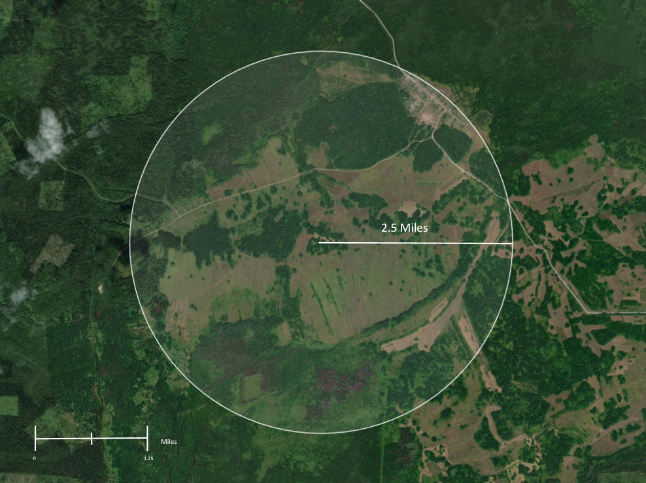

Farmers in the nearctic practice a form of ultra-extensive pastoralism, where ranges span several hundreds of kilometers and change across seasons - this can complicate traditional approaches to rotational models. Left is an area of interest, as indicated by some hypothetical farmer.

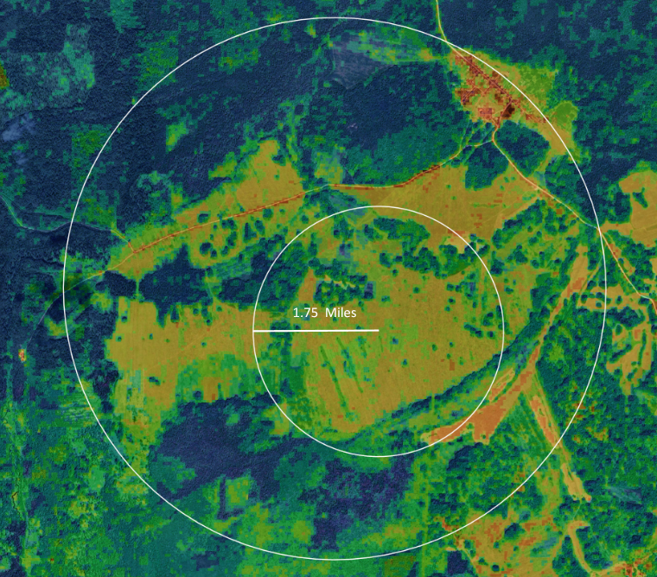

Depending on the Extent of Pastureland, cells will be interpolated to the lowest useful resolution. From USGS’s LANDSAT imagery, I can isolate bands for average insulation (infrared), and chlorophyll. Median cover height is determined using Sentinel-2 data, interpolated with the greater resolution (30m) base. This will be used to delineate 3 zones: shrub (light green), tree (blue), and grass (yellow) using Normalized Difference Vegetation Index (NDVI):

((NIR)- red reflectance (R))/(NIR+R)

Shrubland is prioritized for grazing, but this algorithm also weighs these factors (two of which are spatial):

* Fecundity (moisture index - i.e, grazability)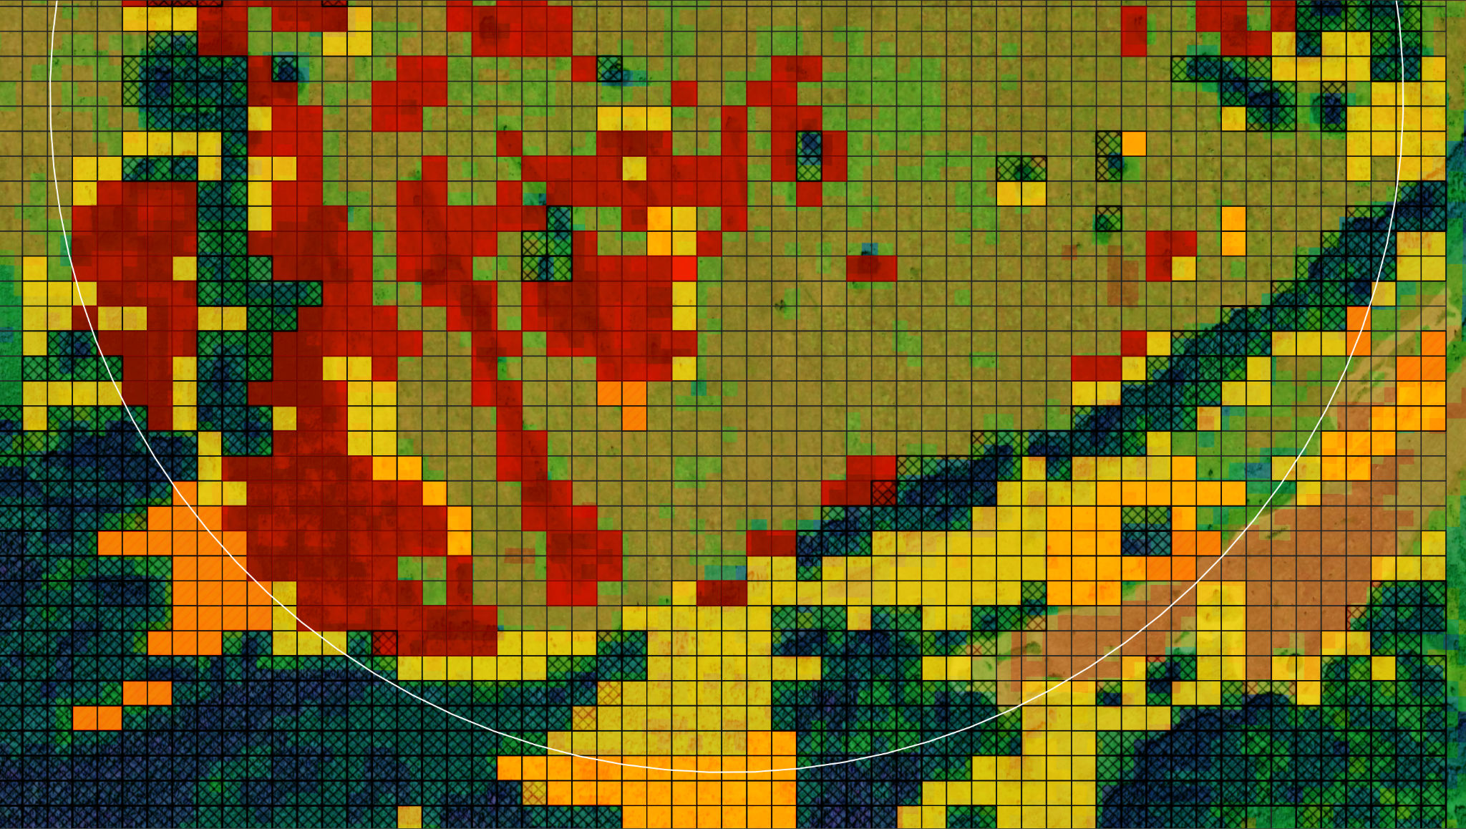
* Current seasonal cattle rotation (hypothetical - I haven’t actually implemented this yet)
* Maximum edginess (shape irregularity - greatest risk of spread)
* Shortest path for farmer (hypothetical - I haven’t actually implemented this yet)

Regions of Interest (identified from above weights) are highlighted in red in the example map:

Red = high priority (++ risk of encroachment)

Orange = modest priority

Yellow = lower priority

**Example SDSS Interface:**

This model is aimed at a hypothetical ‘client’, so I thought providing some dummy-GUI would be useful.

The farmer would draw out the extent of their grazing land (which is important here, as this could be several hundred kilometers), and then be recommended routes for grazing based on their prior input.

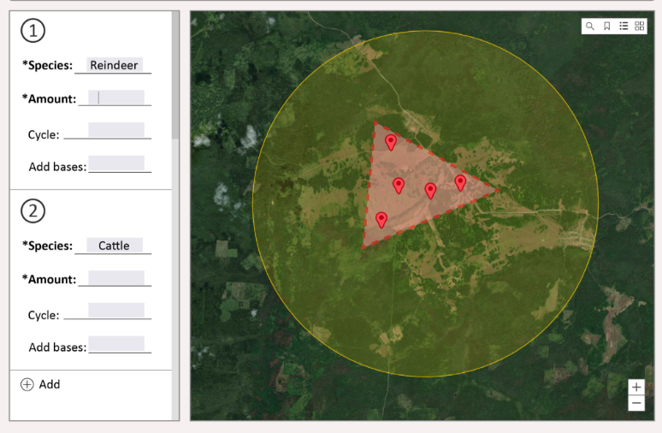

In a more advanced state, I would also take into account livestock number, type (which informs trample tolerance), and topological relationships - factoring in the farmers current seasonal cattle rotation schedule, and minimizing travel between high interest regions using shortest path algos.

This project would include much less pre-existing spatial data (I think all I would need is the LANDSAT/Sentinel 2 data previously mentioned), but I think it has a much stronger spatial element to it. I’m not exactly sure if this is the type of thing you’re looking for, but I thought I’d throw it out there regardless, as I’ve been working on some related stuff (on my own time as a hobby) I thought it may fit.

TL;DR: The environmentalists/municipal govt. would want to minimize the extent of forest encroachment, for greater carbon retention (and more usable land for crops, production of chernozem, etc.), while farmers would also want to take into account *their* most efficient use of the land (in terms of keeping their animals happy, and not having to stray too much from their current routine).

* Evan